UI/UX
All of the programming will be done assuming that normal datapackets are sending in 60 second intervals. Normal data packet will be something like this.
{
"packetId": "PS-H-001-0004821",
"helmetId": "PS-H-001",
"workerId": "W-015",
"timestamp": "2026-08-30T09:45:00+05:30",
"sensors": {
"heartRate": { "value": 92, "valid": true },
"bodyTemp": { "value": 36.8, "valid": true },
"ambientTemp": { "value": 34, "valid": true },
"noise": { "value": 83, "valid": true },
"gas": { "value": 120, "valid": true },
"uv": { "value": 5, "valid": true }
},
"gps": { "lat": 6.9271, "lon": 79.8612, "valid": true, "stale": false },
"emergency": false
}
And emergency data packet will be :
All the logic related details is in the “ProSafe_Processing_Architecture.docx” so match the ui with that when needed

Login page
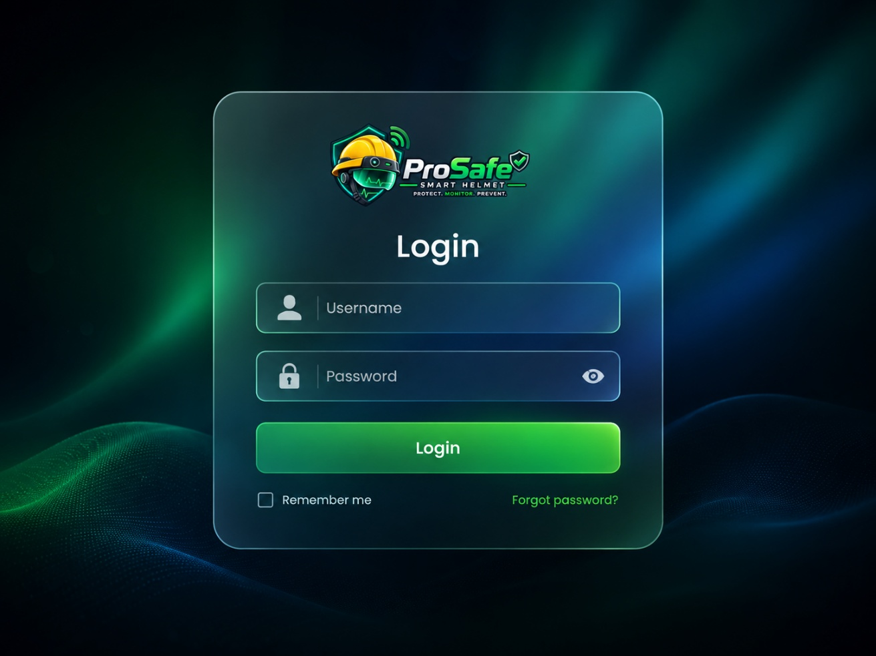
Figure 1: login page
This is the login page of the web application. There are mainly two types of users adminand workers. Based on the user, access levels are different. Sessions also need to track in here
Should be there:
- Sessions should be there.
- Backend function needed for this

Home Page
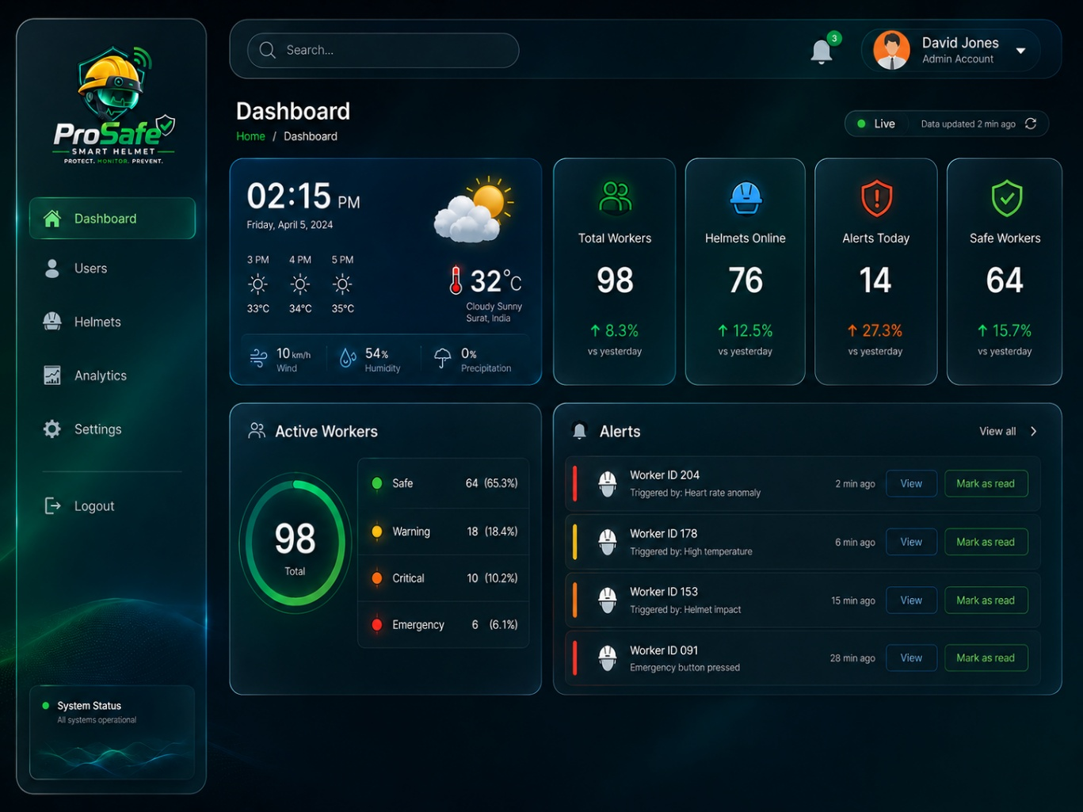
Figure 2: admin home page
This is the admin dashboard home page.
When it comes to the workers dashboard, it is a bit different than this. They only can seeweather info card, alerts for them only in the main dashboard. In the side menu dashboard, user, settings, logout will only be there.
Should be there:
- Backend functions needed –

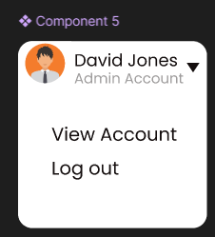
Figure 3: user account drop down view
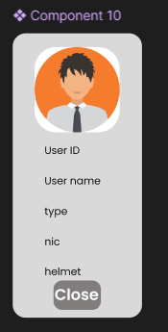
Figure 4: profile details
“Figure 5: profile details” helmet section can be either assigned or not.

Alerts
When the view is clicked in the alert card in the home page, this popup alert window is hovered on top of the home page.
Visible to: admin only
Need to do:
- Define the colors for critical, warning, and emergency
- Notifications should be there
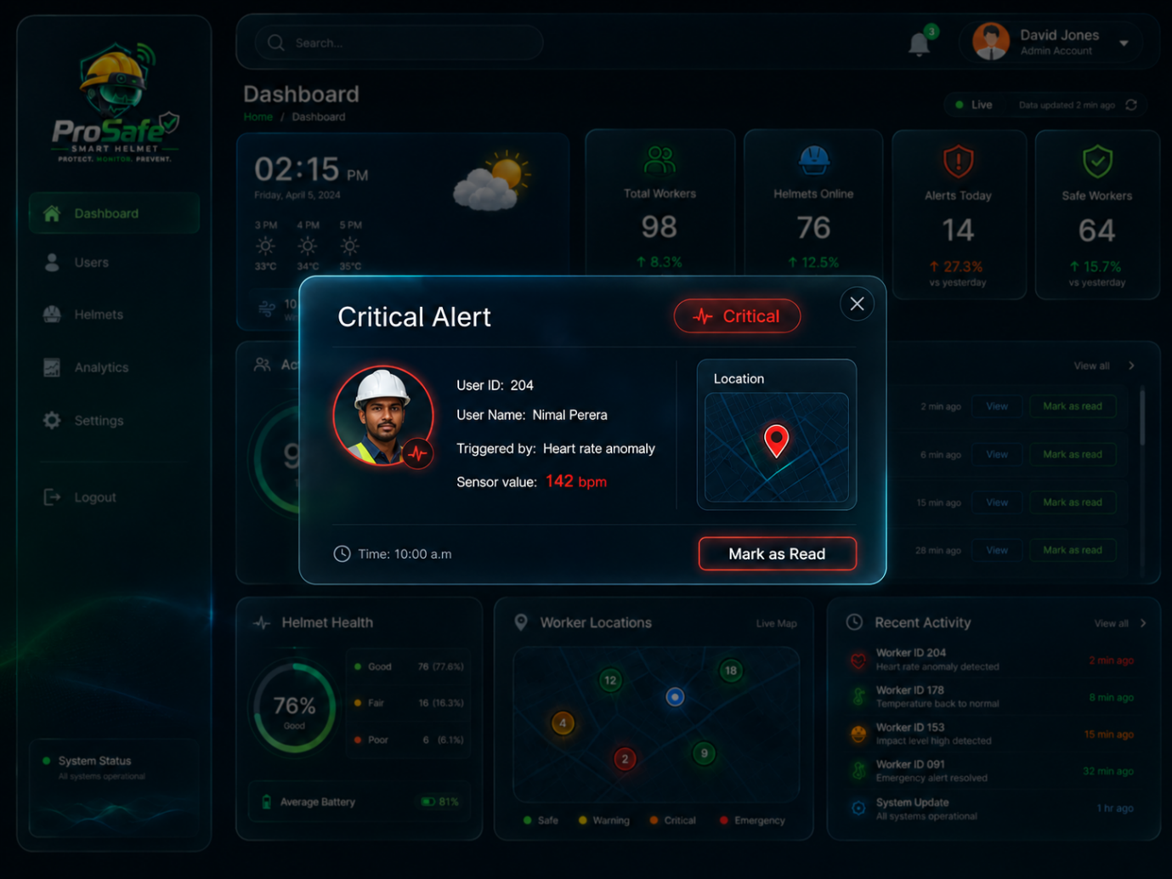
Figure 6: critical alert

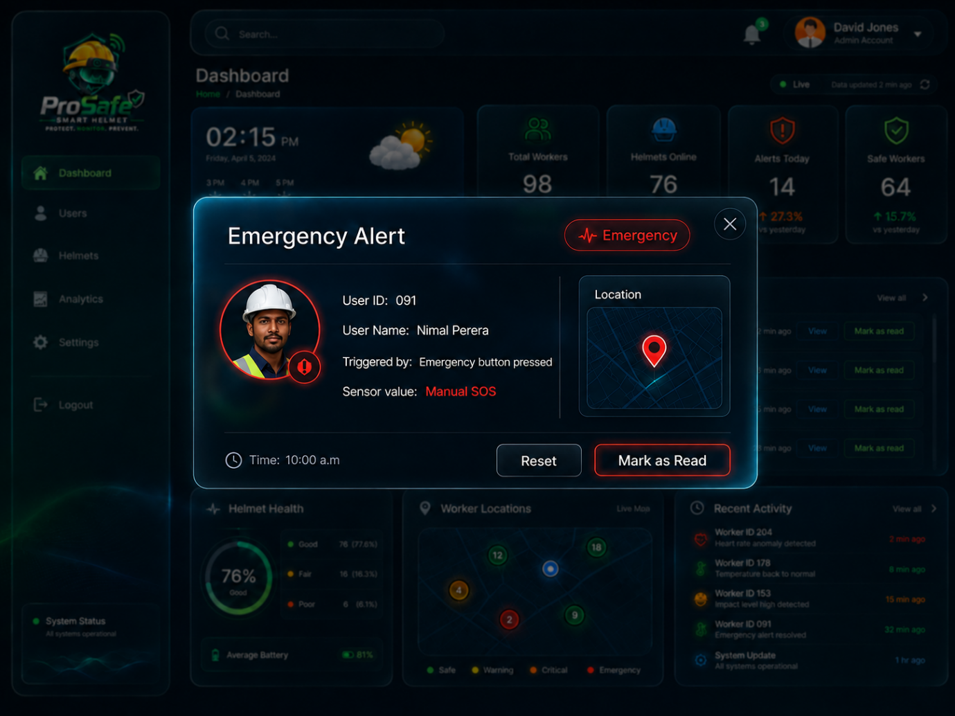
Emergency alerts pop up window have “reset button” to reset the emergency status to the normal state.
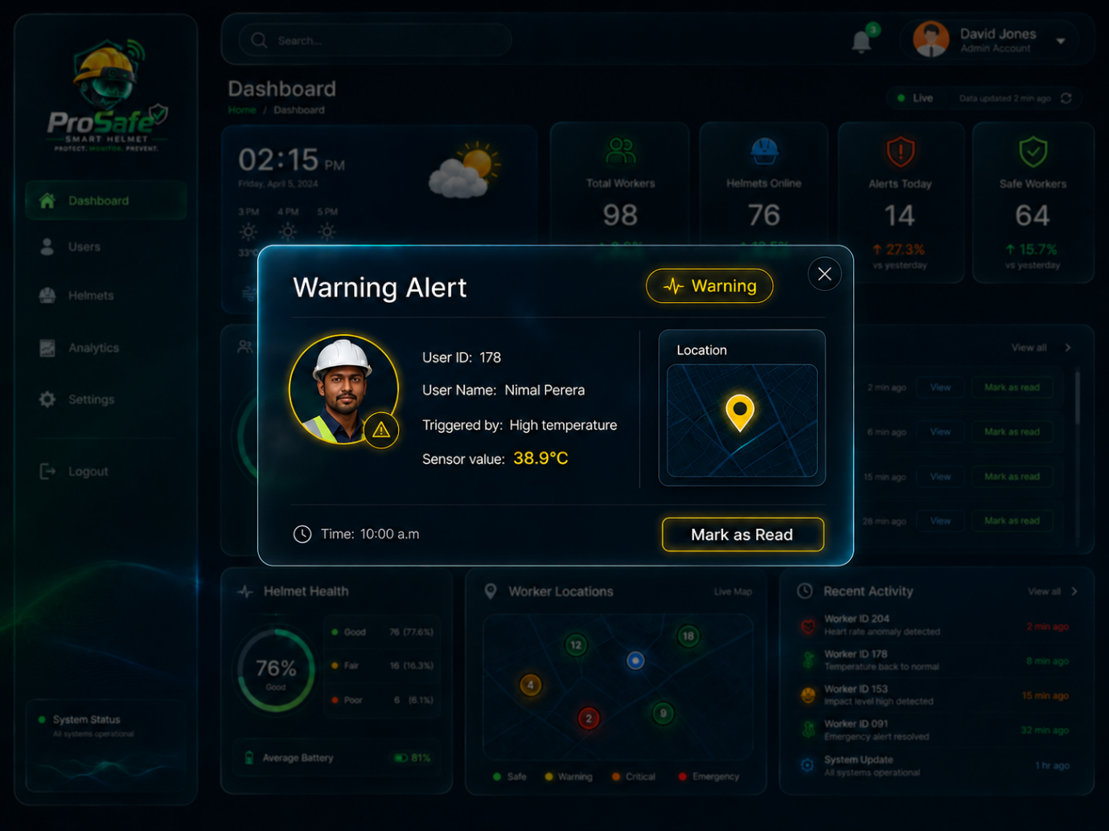

User Page
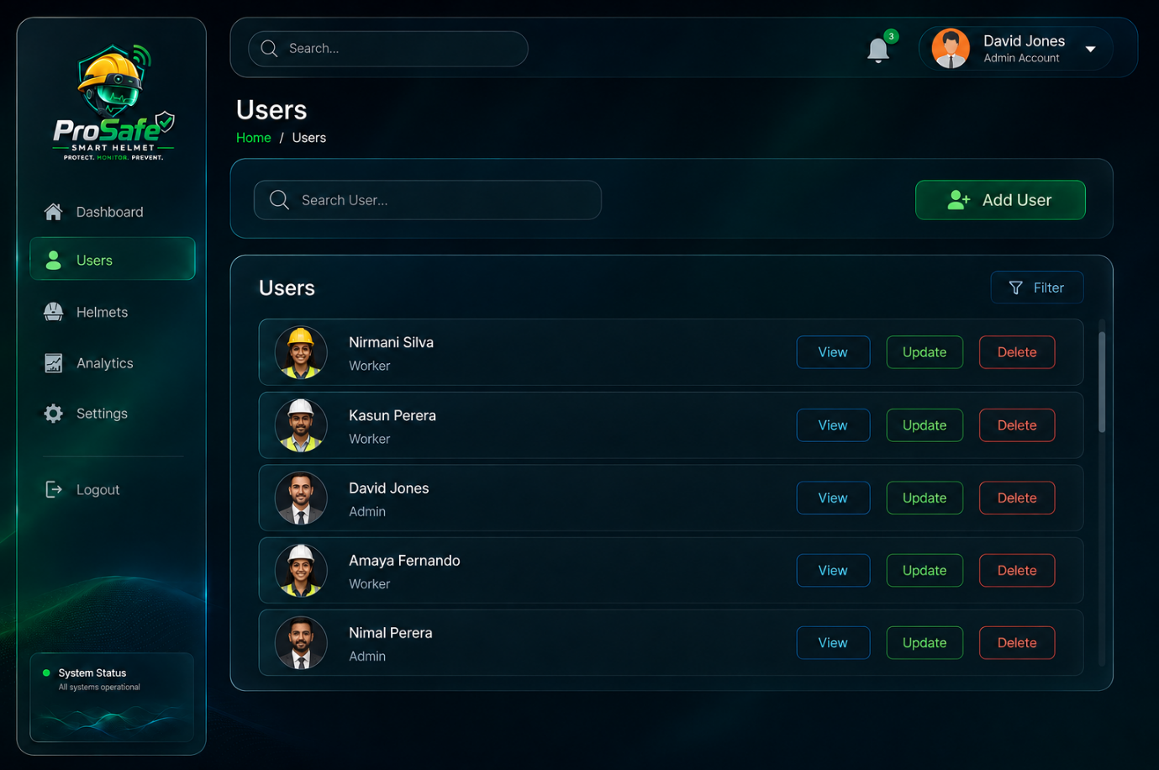
Figure 7: user page
This page lists down the users. The users should be able to filtered.
[note: all user-related things are only visible to admin users only. Worker user types can only check there details only.]

User view
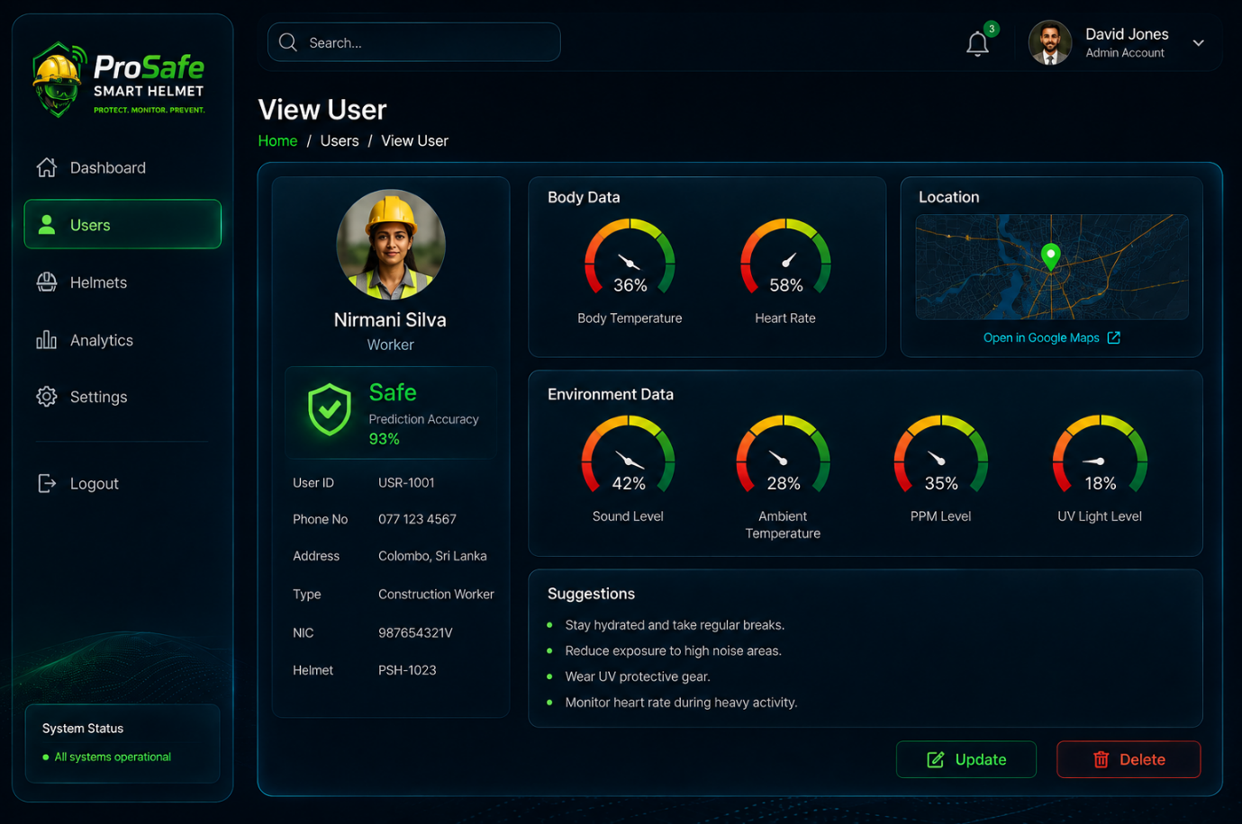
Figure 8: user view page
“Figure 9: user view page” this page is basically show the details of the user. There are admin users and workers. Only workers get assigned to a helmet. So workers view UI shows the readings, safety level of the helmet.
And will give suggestions based on the readings. I need a method to do this, a model or a api.
No need to have gauges like in the picture showing the alue is enough I guess. If there is more suitable way for this tell me.

Body temp/ heart rate - User view
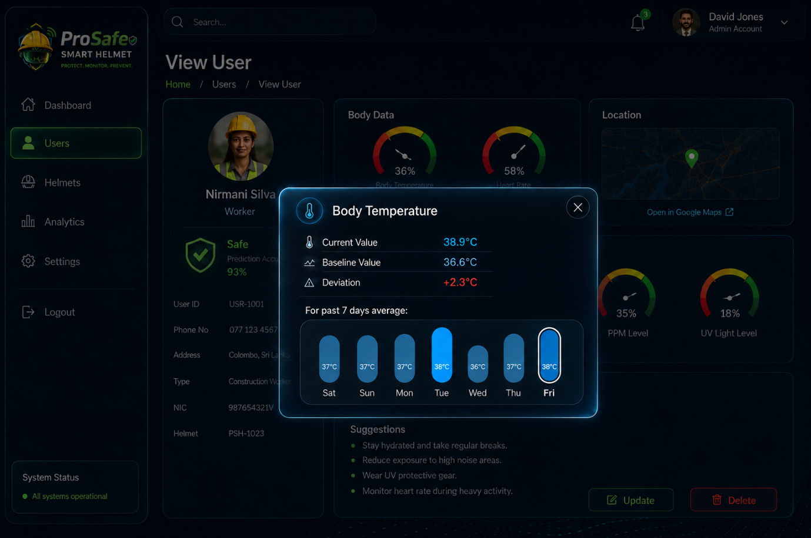
Figure 10
“Figure 10” is the body temperature pop up window. This can be get when clicking the “body temperature” text right after the body temperature gauge on the user view pageThis viewing can only be done for the people who is assigned to a helmet (worker category).
In the below “for past 7 days average” it shows the average values for a day.
Since both body temperature and heart rate is personalized both of them have this pop up window while others are different.

Sound level – user view
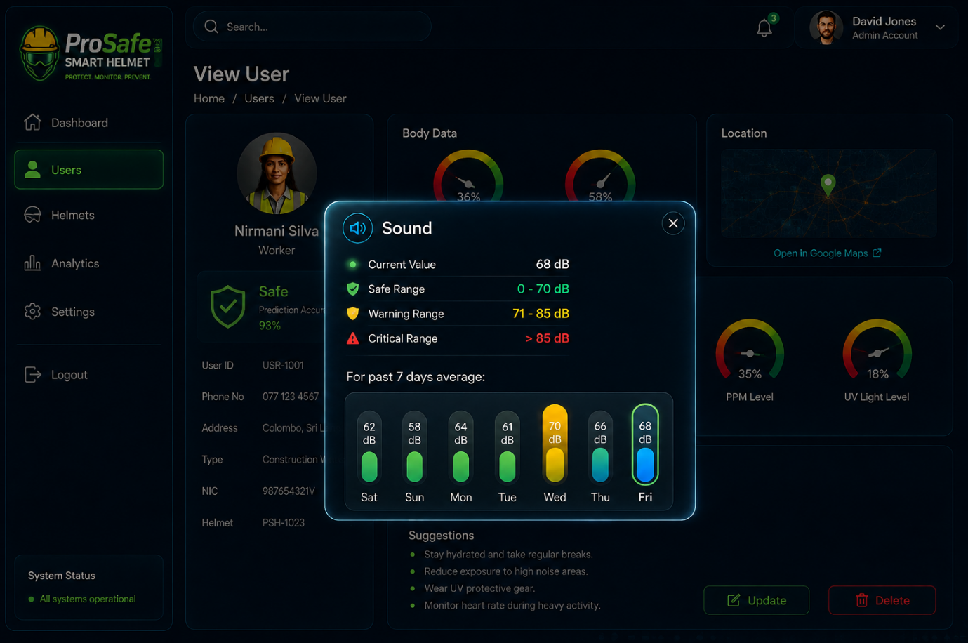
Figure 11
“Figure 11” is the sound level pop up window. This can be get when clicking the “sound level” text right after the sound level gauge on the user view page. This viewing can only be done for the people who is assigned to a helmet (worker category).
In the below “for past 7 days average” it shows the average values for a day.
Since sound level, ambient temperature, ppm level, uv light are not personalized they have this pop up window while body temperature and sound level has the previous (figure 10) pop ups.

Safety prediction – user view
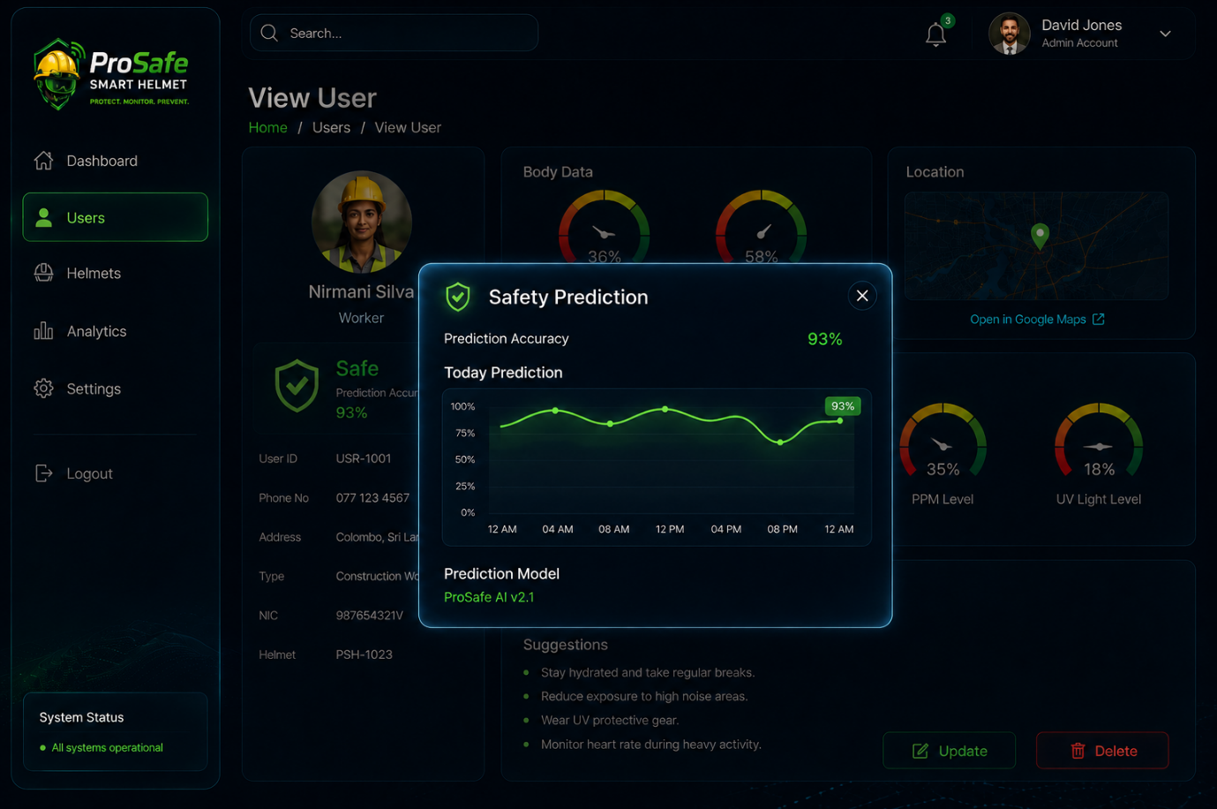
This mainly shows the value of the machine learning model. How the prediction has varied throughout the day. The graph have to be well fomulated and suit for the given context.

User add
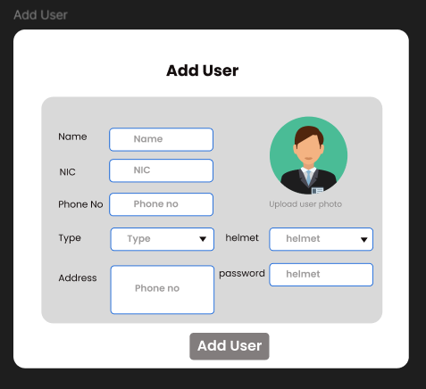
Figure 12
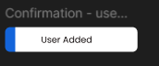
Figure 13
Figure 12 is the form to add users. The email should be there ( I have forgot to add). Figure 12 is just a wireframe. Just like figure 8, the side bar and everything need to be there in add user page full ui.
Once the user hits the “Add user” button, the system should give a toast message like Figure 13, whether it is successful or not.
Function needed:

User edit
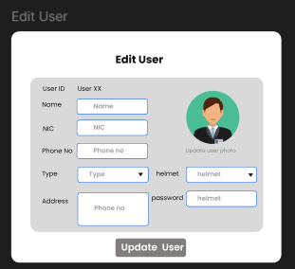
Figure 14
Figure 14 is the form to edit users. The email should be there ( I have forgot to add). Figure 11 is just a wireframe. Just like figure 8, the side bar and everything need to be there in add user page full ui.
Once the user hits the “update user” button, the system should give a toast message like Figure 15, whether it is successful or not.
Function needed:

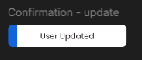
Figure 15

User delete
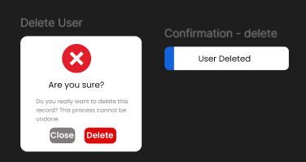
Figure 16
Figure 16 is the confirmation pop up window for deleting a users. It is just a pop up window. Once the user hits the “delete ” button, the system should give a toast message whether it is successful or not. This is also just a wireframe, so need to be matched to the current theme.
Function needed:

Helmet – view
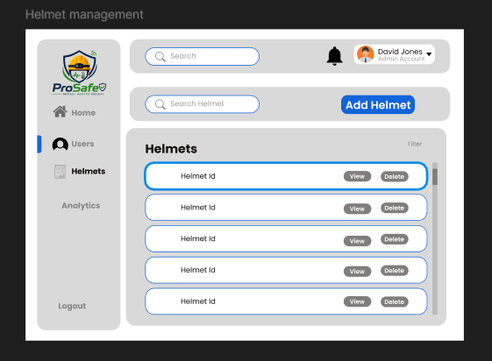
Figure 17
Figure 17 is the helmet wireframe. This also need to match to the current theme and need to add side menus and all.
This lists the available helmets
Function needed:
[note: all helmet-related things are only visible to admin users only]

Add helmet
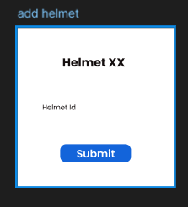
Figure 18
This is a pop up window of add helmet which hovers on top of helmets view page. It only needs the helmet ID to create a helmet. Once the user hits the submit button, it should give a toast message whether it is a success or not. Figure 18 is just a wireframe, so it needs to match to the current theme. If there are more data to be in this form which is relevant add them too.
Function needed:

View helmet
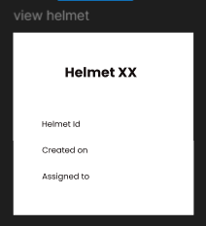
Figure 19
Figure 19 is just a wireframe of helmet view pop up window, so it needs to match to the current theme. This hovers on top of helmets view page.
Function needed:

Delete helmet
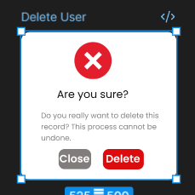
Figure 20
Figure 20 is the confirmation pop up window for deleting a helmet. It is just a pop up window. Once the user hits the “delete ” button, the system should give a toast message whether it is successful or not. This is also just a wireframe, so need to be matched to the current theme.
Function needed:

Analytics view
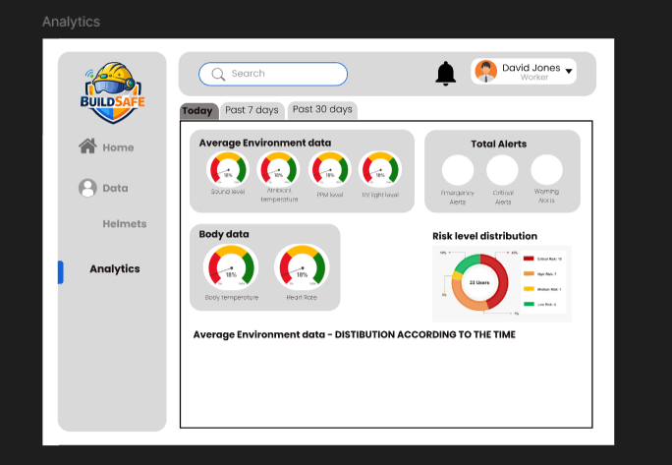
Figure 21
Analytics page is visible only to admin users. Figure 21 is not a solid wireframe because I don’t have much idea of how to add to this. So need suggestions. It should be visiually pleasing, and very comprehensive and be meaningful to improve safety of construction workers.
And the analytics should be downloadable.

settings

